Table of Contents
- 1. Basics of Bluetooth
- 1.1 Introduction of BLE
- 1.2 History of BLE
- 1.2.1. Some of the notable differences are summarized in the following table.
- 1.3 Advantages and Limitations of BLE
- 1.3.1 Limitations of BLE
- 1.3.2 Advantages of BLE
- 1.3.3 Applications Most Suitable for BLE
- 2. Architecture of BLE
- 2.1 Application
- 2.2Host
- 2.3 Controller
- 2.4 Layers of the BLE Architecture
- 2.4.1 Physical Layer (PHY)
- 2.4.2 Link Layer
- 2.4.3 Direct Test Mode
- 2.4.4 Host Controller Interface (HCI) Layer
- 2.4.5 Logical Link Control and Adaptation Protocol (L2CAP) Layer
- 2.4.6 Generic Access Profile (GAP)
- 2.4.6.1 Advertising State
- 2.4.6.2 Scanning State
- 2.4.6.3 Advertising Events
- 2.4.6.4 Advertising Parameters
- 2.4.6.5 Scanning Parameters
- 2.4.7 Attribute Protocol (ATT)
- 2.4.8 Generic Attribute Profile (GATT)
- 2.4.8.1 Services & Characteristics
- 2.4.8.1.1 Services
- 2.4.8.1.2 Characteristics
- 2.4.8.1.3 Profiles
- 2.4.9 Security Manager Protocol
- 3. Glossary of Terms

  - . INTRODUCTION Of BLE
- Bluetooth Low Energy (LE) devices operate in the unlicensed 2.4 GHz ISM (Industrial and fading.
- Two modulation schemes are defined. The mandatory modulation scheme (“1
Msym/s modulation”) uses a shaped, binary FM to minimize transceiver complexity. The symbol rate is 1 Msym/s. An optional modulation scheme (“2 Msym/s modulation”) is similar but uses a symbol rate of 2 Msym/s.
- The 1 Msym/s modulation supports two PHYs:
- LE 1M, with uncoded data at 1 Mb/s.
- LE Coded, with the Access Address, Coding Indicator, and TERM1 coded at125 kb/s and the payload coded at either 125 kb/s or 500 kb/s.
- A device shall support the LE 1M PHY. Support for the LE Coded PHY is optional.
- LE 2M, with uncoded data at 2 Mb/s.
- A Time Division Duplex (TDD) scheme is used on all PHYs. The specification defines the requirements for a Bluetooth radio for the Low Energy radio.
- Provide compatibility between radios used in the system.
- Define the quality of the system.
- An LE radio shall have a transmitter or a receiver, or both the LE radio shall fulfill the stated requirements for the operating conditions declared by the equipment manufacturer.
- The specification is based on the established regulations for Europe, Japan, North America, Taiwan, South Korea and China. The standard documents listed below are only for information and are subject to change or revision at any time.
- Bluetooth started as a short-distance cable-replacement technology to replace wires in devices such as a mouse, a keyboard, or a PC. If you own a modern car or a smartphone, chances are you’ve used Bluetooth at least once in your life. It's everywhere: in speakers, wireless headphones, cars, wearables, medical devices, and even flip-flops!
- The first official version of Bluetooth was released by Ericsson in 1994. It was named after King Harald “Bluetooth” Gormsson of Denmark who helped unify warring factions in the 10th century CE.
- There are two types of Bluetooth devices: one is referred to as Bluetooth Classic (BR/EDR), used in wireless speakers, car infotainment systems, and headsets, and the other is Bluetooth Low Energy (BLE).
- BLE, introduced in Bluetooth version 4.0, is more prominent in applications where power consumption is crucial (such as battery-powered devices) and where small amounts of data are transferred infrequently (such as in sensor applications).
- These two types of Bluetooth devices are incompatible with each other even though they share the same brand and even specification document. A Bluetooth Classic device cannot communicate (directly) with a BLE device.
- Therefore, some devices such as smartphones choose to implement both types (also called Dual Mode Bluetooth devices), allowing them to communicate with both types of devices.

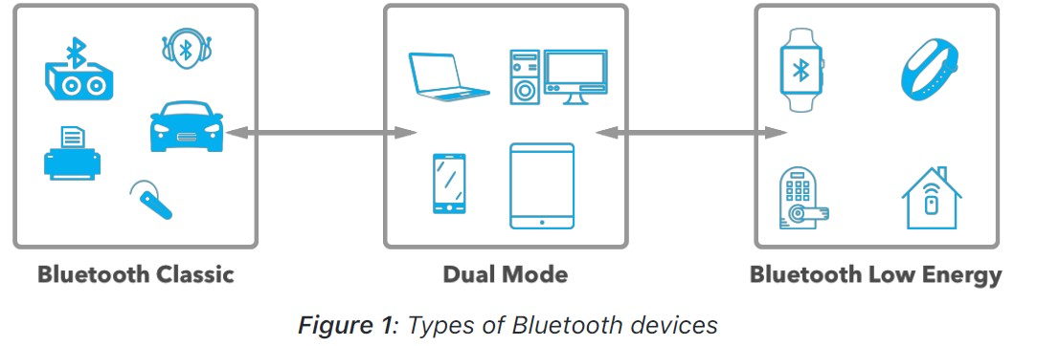
The Here are a few important notes about BLE:
- official Bluetooth specification document combines both types of Bluetooth (Bluetooth Classic and BLE), sometimes making it difficult to locate BLE-specific specifications.
- BLE was introduced in the 4.0 version of the Bluetooth specification, released in 2010.
- BLE is sometimes referred to as Bluetooth Smart or BTLE, and sometimes mistaken as Bluetooth 4.0 (since this version really included both types of Bluetooth).
- Both Bluetooth Classic and BLE operate in the same frequency spectrum (the 2.4 GHz Industrial, Scientific, and Medical (ISM) band).
  - History of BLE

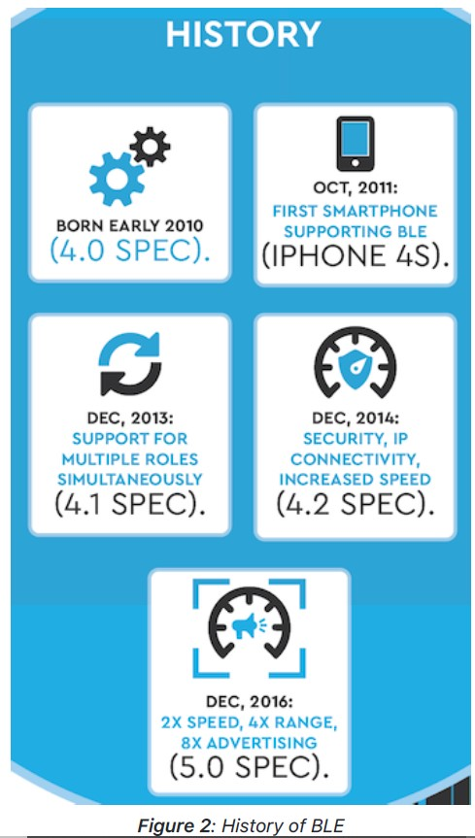

Some the most important technical facts about BLE include:
- The frequency spectrum occupied is 2.400 - 2.4835 GHz.
- The frequency spectrum is segmented into 40 “2 MHz”-wide channels.
- The maximum data rate supported by the radio (introduced in Bluetooth version 5) is 2Mbps.
- The range varies significantly depending on the environment surrounding the communicating BLE devices as well as the mode used (for example, in long-range mode, the range will be significantly longer than in the 2M/high-speed mode). A typical range is 10-30 meters (30-100 feet).
- Power consumption also varies widely. It depends on the implementation of the application, the different BLE parameters, and the chipset used. The peak current consumption of a BLE chipset during radio transmission is typically under 15 mA.
- Security is optional in BLE communication, and it is up to the device and applications developers to implement it. That said, though, there are also varying levels of security that can be implemented.
- For all encryption operations, BLE uses AES CCM with a 128-bit key.
- BLE is designed for low-bandwidth data transfer applications. Implementing BLE for high bandwidth applications will significantly compromise the low power consumption promise. So, minimizing radio usage as much as possible achieves the optimal power consumption.
- Bluetooth versions (when it relates to BLE) are backwards compatible with each other.
However, the communication may be limited to the features of the older version of the two communicating devices.
- For example, a Bluetooth 5 BLE device can communicate with a Bluetooth 4.1 BLE device, but 5-specific features won’t be supported. On the other hand, Connections, Primary Advertisements, discovering Services, discovering Characteristics, and reading/writing to these Characteristics are all possible between two BLE devices regardless of their supported Bluetooth version (since they were supported by the initial version of BLE).

1.2.1. Some of the notable differences are summarized in the following
table:

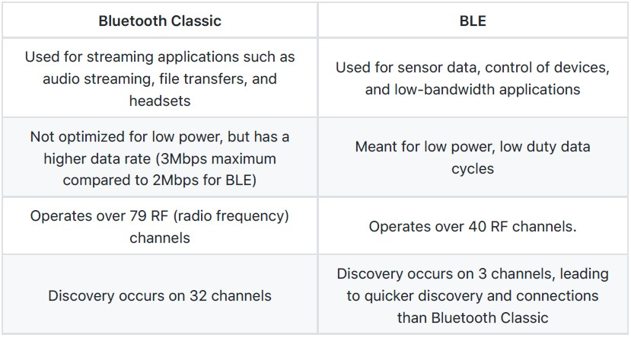

1.3. Advantages and Limitations of BLE
Every technology has its limitations, and BLE is no exception. As we mentioned earlier, BLE is most suitable for applications with relatively short range and infrequent low-bandwidth data transfers.

1.3.1. Limitations of BLE

1. Data Throughput:
The data throughput of BLE is limited by the physical radio data rate, which is the rate at which the radio transmits data. This rate depends on the Bluetooth version used. For
Bluetooth 4.2 and earlier, the rate is the Bluetooth version used. For Bluetooth 4.2 and earlier, the rate is fixed at 1 Mbps. For Bluetooth 5 and later, however, the rate varies depending on the mode and PHY (discussed later in the Physical Layer section) being used. The rate can be at 1 Mbps like earlier versions, or 2 Mbps when utilizing the high-speed feature. When utilizing the long-range feature, the rate drops to either 500 or 125 Kbps. We’ll discuss each of these in more detail in the section on Bluetooth 5.
At the application layer and for the end-user, the data rate is much lower than the radio data rate due to the follow:
- The Gaps in between Packets: Bluetooth specification defines a gap of 150 microseconds between packets being transmitted as a requirement for adhering to the specification. This gap is time lost with no data being exchanged between two devices.
- Packet overhead: All packets include header information and data handled at levels lower than the application level, which count towards the data being transmitted but are not part of the data utilized by your application.
- Slave data packets requirement: The requirement to send back data packets from the slave, even when no data needs to be sent back and empty packets are sent.
- Retransmission of data packets: In the case of packet loss or interference from devices in the surrounding environment, the lost or corrupted data packets get resent by the sender.

2. Range
BLE was designed for short range applications and hence its range of operation is limited. There are a few factors that limit the range of BLE including:
- It operates in the 2.4 GHz ISM spectrum which is greatly affected by obstacles that exist all around us such as metal objects, walls, and water (especially human bodies).
- Performance and design of the antenna of the BLE device.
- Physical enclosure of the device which affects the antenna performance, especially if It’s an internal antenna.
- Device orientation, which effectively relates to the positioning of the antenna (e.g., is smartphones).

- Gateway Requirement for Internet Connectivity
In order to transfer data from a BLE-only device to the Internet, another BLE device that has an IP connection is needed to receive this data and then, in turn, relay it to another IP device (or to the internet).

1.3.2. Advantages of BLE
Even with the previously mentioned limitations of BLE, it has presented some significant advantages and benefits over other similar technologies in the IoT space.

Some of these advantages include:

- Lower power consumption
Even when compared to other low-power technologies, BLE achieves a lower power consumption than its competitors. It's optimized, and less power consumed, by turning the radio off as much as possible, in addition to sending small amounts of data at low transfer speeds.
- No cost to access the official specification documents
With most other wireless protocols and technologies, you would have to become a member of the official group or consortium for that standard in order to access the specification. Becoming a member of those groups can cost a significant amount (up to thousands of dollars per year). With BLE, the major version (4.0, 4.1, 4.2, 5) specification documents are available to download from the Bluetooth website for free.
- Lower cost of modules and chipsets when compared to other similar
technologies.
- Finally, its existence in most smartphones in the market.
This is probably the biggest advantage BLE has over its competitors such as ZigBee, Z-Wave, and Thread.

1.3.3. Applications Most Suitable for BLE
Based on the limitations and benefits we mentioned earlier, there are several use cases where BLE makes the most sense:

- Low-bandwidth data
For cases where a device transfers small amounts of data representing sensor data or for controlling actuators, BLE has proven to be a suitable wireless protocol to utilize.
- Device Configuration
Even in cases where BLE doesn’t satisfy the main requirements of a system, it can still be used as a secondary interface to configure a device before the main wireless connection is established.
For example, some Wi-Fi-enabled devices are adding BLE to configure and establish the Wi-Fi connection of the device instead of using a technology such as Wi-Fi direct (a technology that allows two Wi-Fi devices to connect directly without going through a Wi-Fi router.
- Using a smartphone as an interface
Small, low-power devices usually don’t have large screens and are only capable of displaying limited amounts of data to the end user. Due to the proliferation of smartphones nowadays, BLE can be utilized to offer an alternate, much richer user interface to these small devices (even if just for this sole purpose). Another by-product benefit of using a smartphone is that the data can be relayed up to the cloud.
- Personal and wearable devices
For use cases where a device is portable and can be in areas where no other persistent wireless connections exist (such as WiFi), BLE can be used (since it’s a direct peer-to-peer connection).
- Broadcast-only devices
You’ve probably heard of, and maybe seen, Beacon devices before. These devices have one simple task: to broadcast data so other devices may discover them and read their data. There are other technologies that have been used for this kind of application. However, BLE is becoming more and more popular because most people carry smartphones which already support BLE out-of-the-box.

These are all great use cases that could benefit from utilizing BLE. On the other hand, use cases that are not (generally) suitable for BLE include:
- Video streaming.
- High-quality audio streaming.
- Large data transfers for prolonged periods of time (if battery consumption is a concern).

- Architecture of BLE
The following figure shows the different layers within the architecture of BLE. The three main blocks in the architecture of a BLE device are: the application, the host, and the controller. We’ll focus on the upper-level layers of the architecture, while briefly covering the lower levels of the architecture. We’ll go over each of the lower-level layers in this chapter and then look at each of the upper layers (the Generic Access Profile, the Generic Attribute Profile, the Attribute Protocol, and the Security Manager) each in their own chapter.

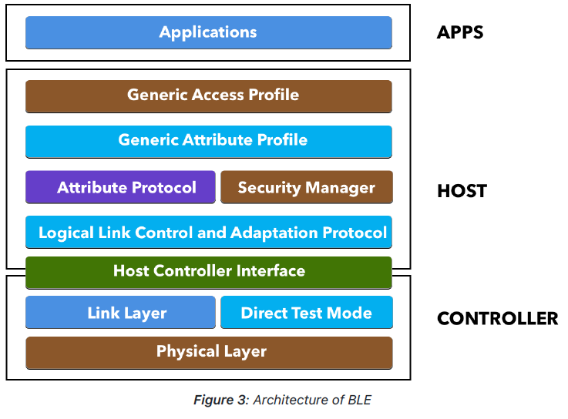

2.1. Application

The application layer is use-case dependent and refers to the implementation on top of the Generic Access Profile and Generic Attribute Profile — it’s how your application handles data received from and sent to other devices and the logic behind it.
This portion is the code that you would write for your specific BLE application and is generally not part of the BLE stack for the platform which you develop. This part will not be covered in the book, since it depends on the specifics of your application and use case.

2.2. Host

The host contains the following layers:
- Generic Access Profile (GAP)
- Generic Attribute Profile (GATT)
- Attribute Protocol (ATT)
- Security Manager (SM)
- Logical Link Control and Adaptation Protocol (L2CAP)
- Host Controller Interface (HCI) — Host side

2.3. Controller

The controller contains the following layers:
- Physical Layer (PHY)
- Link Layer
- Direct Test Mode
- Host Controller Interface (HCI) — Controller side.

  - Layers of the BLE Architecture

2.4.1 Physical Layer (PHY)

The physical layer (PHY) refers to the radio hardware used for communication and for modulating/de-modulating the data. BLE operates in the ISM band (2.4 GHz spectrum), which is segmented into 40 RF channels, each separated by 2 MHz (center-to-center), as
shown in the following figure:

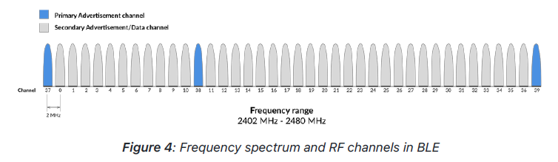

Three of these channels are called the Primary Advertising Channels, while the remaining 37 channels are used for Secondary Advertisements and for data transfer during a connection. We’ll cover these concepts in detail in the chapter titled “Advertising and Scanning”, but let’s briefly cover the concepts here.

Advertising always starts with advertisement packets being sent on the three Primary Advertising Channels (or a subset of these channels). This allows the devices scanning for advertisers to find them and read their advertisement data. The scanner can then initiate a connection if the advertiser allows it. It can also request what’s called a scan request, and if the advertiser supports this scan request functionality, it will respond with a scan response. Scan requests and scan responses allow the advertiser to send additional advertisement data to devices that are interested in receiving this data.

Here are some other important technical details pertaining to the Physical Radio:

- It uses Frequency Hopping Spread Spectrum (FHSS), which allows the two communicating devices to switch to randomly (agreed-on) selected frequencies for exchanging data. This greatly improves reliability and allows the devices to avoid frequency channels that may be congested and used by other devices in the
surrounding environment.
- The transmit power levels are:
- Maximum: 100mW (+20 dBm) for version >= 5, 10mW (+10 dBm) for version <= 4.2
- Minimum: 0.01 mW (-20 dBm)
- In older versions of Bluetooth (4.0, 4.1, and 4.2), the data rate was fixed at 1 Mbps. The physical layer radio (PHY) in this case is referred to as the 1M PHY and is mandatory in all versions including Bluetooth 5. With Bluetooth 5, however, two new optional PHYs were introduced:
- 2Mbps PHY, used to achieve twice the speed of earlier versions of Bluetooth.
- Coded PHY, used for longer range communication.

2.4.2. Link Layer

The link layer is the layer that interfaces with the physical layer (radio) and provides the higher-level layers an abstraction and a way to interact with the radio (through an intermediary level called the HCI layer which we’ll discuss shortly). It is responsible for managing the state of the radio as well as the timing requirements necessary for satisfying the BLE specification. It is also responsible for managing hardware accelerated operations such as: CRC, random number
generation, and encryption.

The three main states in which a BLE device operates in are:
- Advertising state
- Scanning state
- Connected state

When a device advertises, it allows other devices that are scanning to find the device and possibly connect to it. If the advertising device allows connections and a scanning device finds it and
determine to connect to it, they each enter the connected state.

The link layer manages the different states of the radio, shown in the following figure:

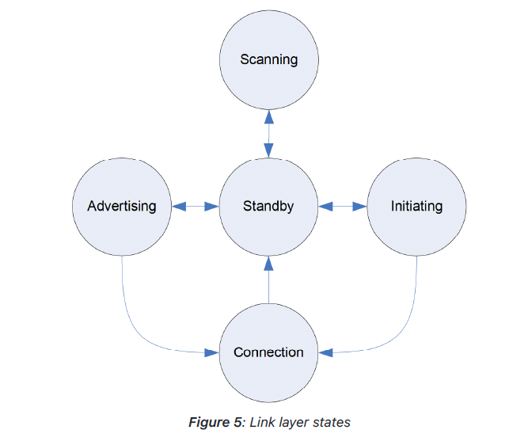

- Standby: the default state in which the radio does not transmit or receive any data.
- Advertising: the state in which the device sends out advertising packets for other devices to discover and read.
- Scanning: the state in which the device scans for devices that are Advertising
- Initiating: the state in which a scanning device decides to establish a connection with a device that is advertising.
- Connected: the state in which a device has an established link with another device and regularly exchanges data with this other device. This applies to both a device that was in the advertising state or one that was scanning for advertisements and then decided to initiate a connection with the advertising device. In this connected state, the device that initiates the connection is called the master, and the device that was advertising is now called the slave.

Bluetooth Address

Bluetooth devices are identified by a 48-bit address, like a MAC address. There are two main types of addresses: Public Addresses and Random Addresses.

Public Address
This is a fixed address that does not change and is factory-programmed. It must be registered with the IEEE (like a WiFi or Ethernet device MAC address).

Random Address
Since manufacturers have a choice on what type of address to use (Random vs. Public), Random addresses are more popular since they do not require registration with the IEEE. A random address is programmed on the device or generated at runtime. It can be one of two sub-types:
- Static Address
- Used as a replacement for public addresses.
- Can be generated at boot up OR stay the same during lifetime.
- Cannot change until a power cycle.
- Private address
This one is also split up into two additional sub-types:
- Non-resolvable Private Address:
- Random, temporary for a certain time.
- Not commonly used.
- Resolvable Private Address:
- Used for privacy.
- Generated using Identity Resolving Key (IRK) and a random number.
- Changes periodically (even during the lifetime of the connection).
- Used to avoid being tracked by unknown scanners
- Trusted devices (or Bonded, which is described later in the chapter on Security) can resolve it using the previously stored IRK.

2.4.3. Direct Test Mode

Direct Test Mode (DTM) is only needed for performing RF tests and used during manufacturing and for certification tests. This layer is beyond the scope of this book, so we won’t get into it in any detail.

2.4.4. Host Controller Interface (HCI) Layer

The HCI layer is a standard protocol defined by the Bluetooth specification that allows the host layer to communicate with the controller layer. These layers could exist in separate chipsets, or they could exist in the same chipset. In this sense, it also allows interoperability between chipsets, so a device developer can choose two Bluetooth certified devices, a controller and a host, and be 100% confident that they are compatible with each other in terms of communication between the host and controller layers.
In the case where the host and controller are in separate chipsets, the HCI layer will be implemented over a physical communication interface. The three officially supported hardware interfaces by the spec are: UART, USB, and SDIO (Secure Digital Input Output). In the case where the two layers (host and controller) live on the same chipset, the HCI layer will be a logical interface instead.

The job of the HCI layer is to relay commands from the host down to the controller and send events back up from the controller to the host. Following is an example of a capture of HCI commands, HCI events, and ATT commands being exchanged between the host and controller
layers:

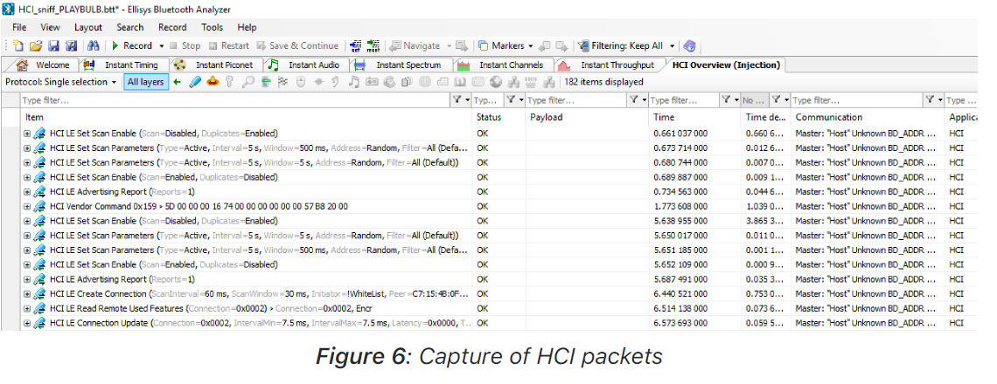

Examples of the messages include command packets, configuring the controller, requesting actions, controlling the connection and connection parameters, event packets, command completion and status events.

2.4.5. Logical Link Control and Adaptation Protocol (L2CAP) Layer

The Logical Link Control and Adaptation Protocol (L2CAP) layer acts as a protocol multiplexing layer. It is borrowed from the Bluetooth Classic
standard, and performs the following tasks in the case of BLE:

- Takes multiple protocols from the upper layers and places them in standard BLE packets that are passed down to the lower layers beneath it.
- Handles fragmentation and recombination. It takes the larger packets from the upper layers and splits them into chunks that fit into the maximum BLE payload size supported for transmission. On the receiver side, it takes multiple packets and combines them into one packet that can be handled by the upper layers.

For BLE, the L2CAP layer handles two main protocols: the Attribute Protocol (ATT) (covered in the chapter on GATT), and the Security Manager Protocol (SMP).

2.4.6. Generic Access Profile (GAP)

The Generic Access Profile (GAP) provides the framework that defines how BLE devices interact with each other. This includes the following aspects:
- Modes & Roles of BLE devices.
- Advertisements (advertising, scanning, advertising parameters, advertising data, scanning parameters).
- Connection establishment (initiating, accepting, connection parameters)
- Security.

The implementation of this framework is mandatory per the official specification, and it is what allows two or more BLE devices to interoperate, communicate, and be able to exchange data with each other.
We talked briefly about the advertising and scanning states of a BLE device, and we mentioned that a BLE device always starts in the advertising state. This is the case even when it wants to operate in the connected state most of the time. For two BLE devices to discover each other, one of them must advertise while the other scans the three Primary Advertising channels (RF channels 37, 38, and 39) looking for advertisement packets sent by the advertising device.

If the advertising device supports a connection and a central device discovers it, it may choose to establish a connection. In this chapter, we will focus on these initial states: advertising and scanning.

2.4.6.1. Advertising State

In the advertising state, a device sends out packets containing useful data for others to receive and process. The packets are sent at a fixed interval defined as the advertising interval.

There are 40 RF channels in BLE, each separated by 2 MHz (center-to-center), as shown in the following figure. Three of these channels are called the Primary Advertising Channels, while the remaining 37 channels are used for Secondary Advertisements and for data packet transfer during a connection.

Note: Since these are the three channels that a device starts by advertising on, and usually switches between them, they are spread apart in the frequency spectrum to avoid radio interference between a device that's advertising on one channel and another that's advertising on a different channel. Also, the locations of these primary channels (RF channels 37, 38, and 39) were chosen within the spectrum to avoid interference with the most used WiFi channels.

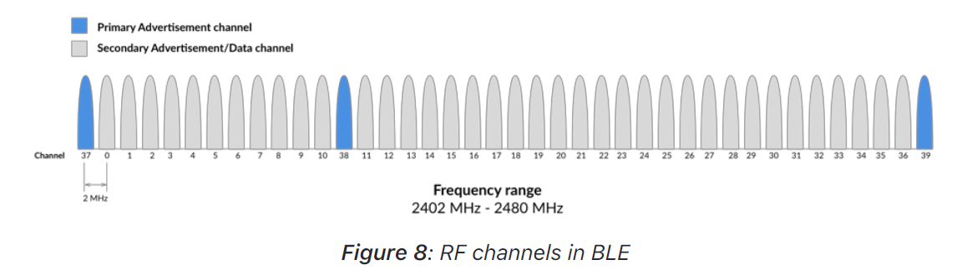

Advertisements always start with advertisement Packets sent on the three Primary Advertising Channels (or a subset of these channels). This allows centrals to find the advertising device (peripheral) and parse its advertisement packets. The central can then initiate a connection if the advertiser allows it.

The central can also request what’s called a scan request, and if the Advertiser supports it, it will respond with a scan response. Scan requests and responses allow the advertiser to send additional advertising data that would not fit in the initial advertisement packet.

Note: Primary advertisement data is limited to 31 bytes. Secondary advertisement data, on the other hand, supports up to 254 bytes of data.

As we’ve mentioned before, some devices (broadcasters) stay in the advertising state and do not accept connections (connectionless), while others (peripherals) allow the transition to the connected state if a central initiate a connection (connection-oriented). For example,
most Beacons stay in the advertising state during the lifetime of the device.

The main advantage of staying in the advertising state is that multiple centrals can discover the advertising data without the need for a connection. However, the downsides are the lack of security and the inability for the advertiser to receive data from a central (data transfer is unidirectional).

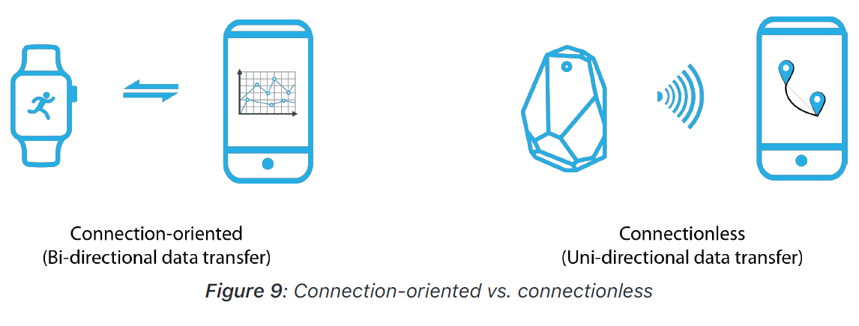
2.4.6.2. Scanning State

A device that listens for advertisements, and then sends scan Requests from the advertisers is defined to be in the active scanning mode, while a device that passively listens to advertising packets and does not send scan requests is said to be in the passive scanning mode.

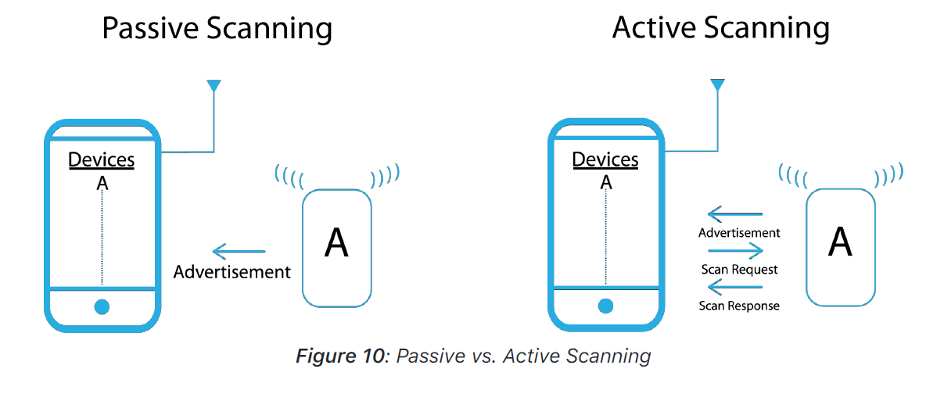

2.4.6.3 Advertising Events

An advertising event is made up of multiple advertising packets being sent on all, or a subset of, the three Primary Advertising Channels (37, 38, and 39). There are seven types of advertising events (think of these as the different types of advertising packets):
- Connectable and Scannable Undirected Event
This type allows other devices to receive the advertisement packets, send a scan request to the advertiser, and establish a connection with it.
- Connectable Undirected Event
This type allows other devices to receive the advertisement packets and establish a connection with the advertiser.
- Connectable Directed Event
This type allows a specific device to receive the advertisement packets and establish a connection with the advertiser.
- Non-Connectable and Non-Scannable Undirected Event
This type allows other devices to receive its advertisement packets. However, it does not allow scan requests or the establishment of a connection with the advertiser.
- Non-Connectable and Non-Scannable Directed Event
This type allows a specific device to receive the advertisements without the ability to establish a connection with the advertiser or to send scan requests.
- Scannable Undirected Event
This type allows other devices to send a scan request to the advertiser to receive additional advertisement data.
- Scannable Directed Event
This type allows a specific device to send a scan request to the advertiser to receive additional advertisement data.

2.4.6.4. Advertising Parameters

The different advertising parameters are:

- Advertising Interval
The most important parameter related to advertisements is the advertising interval. The advertising interval value ranges all the way from 20 milliseconds up to 10.24 seconds in small increments of 625 microseconds. The advertising interval greatly impacts battery life and should be chosen carefully. It’s recommended to choose the longest advertising interval that provides a balance between fast connectivity and reduced power consumption.

- Advertising/Scan Response Data
Let’s look at what fields are usually included in an
advertisement packet, and what the packet format looks like.
Note that scan responses share the same format.

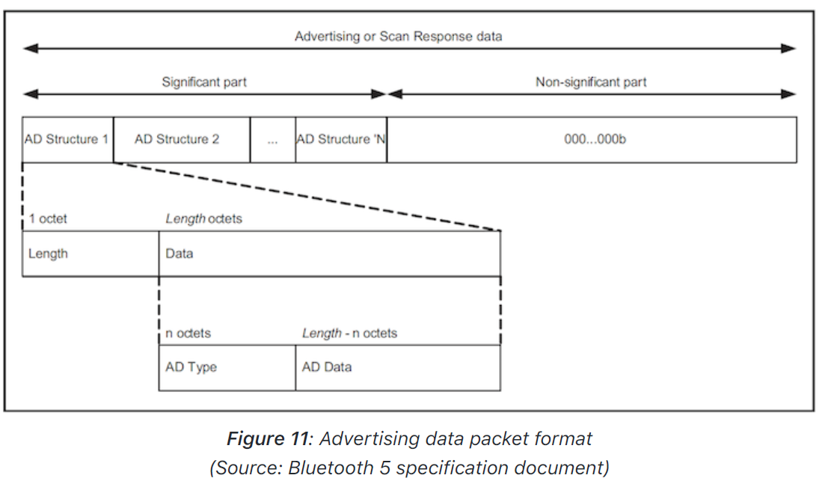

- Length: The length of the data that follows the length value itself (includes the AD Type as well as the AD Data).
- Advertising Data Type (AD Type): The type of advertisement data included in this specific TLV.
- Advertising Data: The actual value of the advertisement data.

Some of the most used AD Types:

- Local Name: contains the device name that is read by scanners that discover the advertising device.
- Tx Power Level: transmit power level, defined in units of dBm.
- Flags: multiple one-bit Boolean (a binary variable, having two possible values: TRUE [1] or FALSE [0]) flags, including:
- Limited Discoverable Mode
- General Discoverable Mode
- BR/EDR Not Supported
- Simultaneous LE and BR/EDR to Same Device Capable (controller)
- Simultaneous LE and BR/EDR to Same Device Capable (host)
- Service Solicitation: a list of one or more UUIDs indicating what services are supported and exposed by the device’s GATT server. This helps central devices learn the available services (explained in a later chapter) exposed by a device before establishing a connection.
- Appearance: this defines the external appearance of the device according to the Bluetooth Assigned Numbers. These include appearances such as phone, heart rate sensor, key ring and many more.
If you cannot find an appearance that fits the nature of your device, you can use the UNKNOWN APPEARANCE value.

2.4.6.5. Scanning Parameters

The three main scanning parameters are:
- Scan Type: Passive vs. Active Scanning.
- Scan Window: indicates how long to be scanning for advertisements.
- Scan Interval: indicates how often to scan for advertisements.

The scanner will listen for the complete scan window at every scan interval, and in each scan window it will listen on a different Primary Advertising Channel. Scan window and scan interval are configurable aspects of a scanner’s behavior.

2.4.7. Attribute Protocol (ATT)

ATT defines how a server exposes its data to a client and how this data is structured. There are two roles within the ATT:
- Server:
This is the device that exposes the data it controls or contains, and possibly some other aspects of server behavior that other devices may be able to control. It is the device that accepts incoming commands from a peer device, and sends responses, notifications and indications.

For example, a thermometer device will behave as a server when it exposes the temperature of its surrounding environment, the unit of measurement, its battery level, and possibly the time intervals at which the thermometer reads and records the temperature. It can also notify the client (defined later) when a temperature reading has changed rather than have the client poll for the data waiting for a change to occur.
- Client:
This is the device that interfaces with the server with the purpose of reading the Server’s exposed data and/or controlling the server’s behavior. It is the device that sends commands and requests and accepts incoming notifications and indications. In the previous example, a mobile device that connects to the thermometer and reads its temperature value is acting in the Client role.

The data that the server exposes is structured as attributes. An attribute is the generic term for any type of data exposed by the server and defines the structure of this data. For example, services and characteristics (both described later) are types of attributes. Attributes are made up of the following:

- Attribute type (Universally Unique Identifier or UUID)
This is a 16-bit number (in the case of Bluetooth SIG-Adopted Attributes), or 128-bit number (in the case of custom attribute types defined by the developer, also sometimes referred to as vendor-specific UUIDs).

For example, the UUID for a SIG-adopted temperature measurement value is 0x2A1C SIG-adopted attribute types (UUIDs) share all but 16 bits of a special 128-bit base UUID:

00000000-0000-1000-8000-00805F9B34FB

The published 16-bit UUID value replaces the 2 bytes in bold is the base UUID.

A custom UUID, on the other hand, can be any 128-bit number that does not use the SIG-adopted base UUID. For example, a developer can define their own attribute type (UUID) for a temperature reading as:

F5A1287E-227D-4C9E-AD2C-11D0FD6ED640

One benefit of using a SIG-adopted UUID is the reduced packet size since it can be transmitted as the 16-bit representation instead of the full 128-bit value.

- Attribute Handle
This is a 16-bit value that the server assigns to each of its attributes — think of it as an address. This value is used by the client to reference a specific attribute and is guaranteed by the server to uniquely identify the attribute during the life of the connection between two devices. The range of handles is 0x0001-0xFFFF, where the value of 0x0000 is reserved.
- Attribute Permissions
Permissions determine whether an attribute can be read or written to, whether it can be notified or indicated, and what security levels are required for each of these operations. These permissions are not defined or discovered via the Attribute Protocol (ATT), but rather defined at a higher layer (GATT layer or Application layer).

The following figure shows a logical representation of an Attribute:

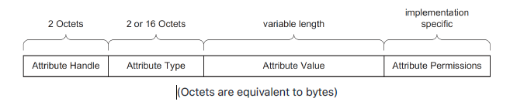

Fig: Logical representation of an attribute
(Source: Bluetooth 5 specification document)

2.4.8. Generic Attribute Profile (GATT)

Now that we’ve covered the concept of attributes, we’ll go over three important concepts in BLE that you will come across very often:

- Services
- Characteristics
- Profiles

These concepts are used specifically to allow hierarchy in the structuring of the data exposed by the Server. Services and characteristics are types of attributes that serve a specific purpose. Characteristics are the lowest level attribute within a database of
attributes. Profiles are a bit different and are not discovered on a server — we will explain them later in this chapter.

The GATT defines the format of services and their characteristics, and the procedures that are used to interface with these attributes such as service discovery, characteristic reads, characteristic writes, notifications, and indications.

GATT takes on the same roles as the Attribute Protocol (ATT). The roles are not set per device — rather they are determined per transaction (such as request ⟷ response, indication ⟷ confirmation, notification). So, in this sense, a device can act as a server serving up data for clients, and at the same time act as a client reading data served up by other servers (all during the same connection).

2.4.8.1. Services & Characteristics

2.4.8.1.1. Services

A service is a grouping of one or more attributes, some of which are characteristics. It’s meant to group together related attributes that satisfy a specific functionality on the server. For example, the SIG-adopted battery service contains one characteristic called the battery level.

A service also contains other attributes (non-characteristics) that help structure the data within a service (such as service declarations, characteristic declarations, and others).

Here’s what a service looks like:

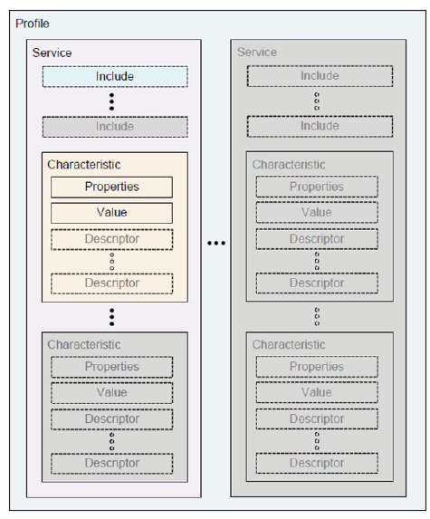
Fig: Profiles, Services, and Characteristics
(Source: Bluetooth 5 specification document)

From the figure, we can see the different attributes that a service is made up of:
- One or more include services
- One or more characteristics
- Characteristic properties
- A characteristic value
- Zero or more characteristic descriptors
An include service allows a service to refer to other services for purposes such as extending the included service. There are two types of services:

- Primary Service: represents primary functionality of a device.
- Secondary Service: provides auxiliary functionality of a device and is referenced (included) by at least one other primary service on the device (it is rarely used and won’t be referenced in this book).

2.4.8.2. Characteristics

A characteristic is always part of a service, and it represents a piece of information/data that a server wants to expose to a client. For example, the battery level characteristic represents the remaining power level of a battery in a device which can be read by a client. The characteristic contains other attributes that help define the value it holds:

- Properties: represented by a number of bits and which defines how a characteristic value can be used. Some examples include read, write, write without response, notify, indicate.
- Descriptors: used to contain related information about the characteristic Value. Some examples include extended properties, user description, fields used for subscribing to notifications and indications, and a field that defines the presentation of the value such as the format and the unit of the value.

2.4.8.3. Profiles

Profiles are much broader in definition than services. They are concerned with defining the behavior of both the client and server when it comes to services, characteristics and even connections and security requirements. Services and their specifications, on the other hand,
deal with the implementation of these services and characteristics on the server side only.

Just like in the case of services, there are also SIG-adopted profiles that have published
specifications. In a profile specification, you will generally find the following:
- Definition of roles and the relationship between the GATT server and client.
- Required Services.
- Service requirements.
- How the required services and characteristics are used.
- Details of connection establishment requirements including advertising and connection
parameters.
- Security considerations.

Following is an example of a diagram taken from the Blood Pressure Profile specification
document. It shows the relationship between the roles (server, client), services, and
characteristics within the profile.

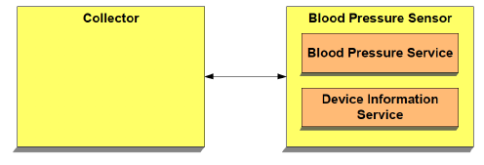

Fig: Blood pressure profile
(Source: Blood Pressure Profile specification document)

2.4.9. Security Manager Protocol

Security in BLE is handled by the security manager (SM) layer of the architecture. It is
shown in the following diagram:

The security manager defines the protocols and algorithms for generating and exchanging
keys between two devices. It involves five security features:

- Pairing: the process of creating shared secret keys between two devices.
- Bonding: the process of creating and storing shared secret keys on each side (central
and peripheral) for use in subsequent connections between the devices.
- Authentication: the process of verifying that the two devices share the same secret
keys.
- Encryption: the process of encrypting the data exchanged between the devices.
Encryption in BLE uses the 128-bit AES Encryption standard, which is a symmetric-key
algorithm (meaning that the same key is used to encrypt and decrypt the data on both
sides).
- Message Integrity: the process of signing the data, and verifying the signature at the
another end. This goes beyond the simple integrity check of a calculated CRC.

The Bluetooth specification has evolved over time to provide stronger security measures.
This is especially true for BLE, which introduced the concept of LE Secure Connections
(LESC) in version 4.2. LESC utilizes the Elliptic-curve Diffie-Hellman (ECDH) protocol during
the pairing process (covered later in this chapter), which makes the communication much
more secure compared to the methods used in earlier versions of Bluetooth.

Bluetooth 4.2 also introduced the term legacy connections, which collectively refers to the
pairing methods defined by the earlier specification versions. It’s important to note, though,
that legacy connections are still supported in Bluetooth 4.2 and later. We’ll cover the
differences between these methods in the upcoming sections.

The Security Manager addresses the different security concerns as follows:
- Confidentiality via encryption.
- Authentication via pairing & bonding.
- Privacy via resolvable private addresses.
- Integrity via digital signatures.

In BLE, the master device is the initiator of security procedures. The slave (responder) may
request the start of a security procedure by sending a security request message to the
master, but it is up to the master to then send the packet that officially starts the security
process.

To better understand how security works in BLE, we need to understand two important
concepts: pairing and bonding. But first, let’s review a sequence diagram showing the
security process:

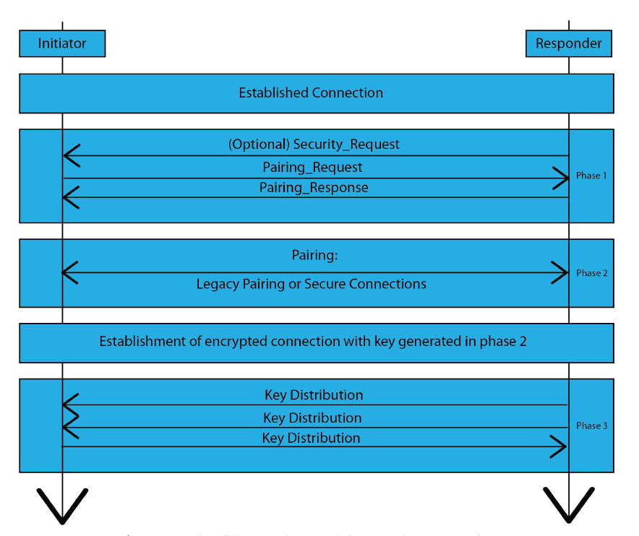
Fig: The different phases of the security process in BLE

Pairing is the combination of Phases 1 and 2. Bonding is represented by Phase 3 of the process. One important thing to note is that Phase 2 is the only phase that differs between LE Legacy Connections and LE Secure Connections.

3.Glossary of Terms

2M PHY: a mode introduced in Bluetooth 5 in which the radio transmits data at a rate of 2
Mega symbols/second.
Active Eavesdropping: a special case of man-in-the-middle (MITM) attacks, in which the
attacker makes independent connections with the victims and relays messages between
them to make them believe they are talking directly to each other over a private connection,
when in fact the entire conversation is controlled by the attacker.
Advertising: the link layer state in which the device is sending out advertising packets for
other BLE to discover it.
AES CCM: an authenticated encryption algorithm designed to provide both authentication
and confidentiality.
Application: the top level of the BLE architecture which implements the particular use case
of the BLE device.
ATT (Attribute Protocol): a simple protocol for devices to list attributes that allow different
operations such as write and read.
Attribute: a generic term for any type of data exposed by a BLE server. It also defines the
structure of this data.
Authentication: the process or action of verifying the identity of a user, device, or process.
Auxiliary Packets: this is the same as the secondary advertisement packets.
Beacon: a BLE device that broadcasts advertisement packets for the sole purpose of being
discovered by other BLE devices. Usually, a beacon does not enter the connected state.
BLE: Bluetooth Low Energy.
Bluetooth Classic: a short-range wireless technology focused on streaming applications
such as audio streaming.
Bluetooth Low Energy: a short-range wireless technology focused on low-power and low bandwidth
applications.
Bluetooth stack: software that refers to an implementation of the Bluetooth protocol.
Bonding: a process where the information from the pairing process is stored on the devices
so that the pairing process does not have to be repeated every time the devices reconnect
to each other.
BR/EDR: Basic Rate/Enhanced Data Rate (Bluetooth Classic).
Broadcaster: a BLE device that sends out advertising packets and does not allow other BLE
devices to connect to it.
Central: a BLE device (usually a smartphone/tablet/PC) that listens for peripheral devices
that are advertising. It is also capable of connecting to peripherals, and is responsible for
managing the connection via its various parameters.
Channel Hopping: the act of rapidly switching between different frequencies, using a
pseudorandom frequency-selection algorithm agreed on by the transmitter and receiver.
Characteristic: a container for a piece of user data, usually coupled with metadata
describing it (such as being writeable, readable, its description, etc.).
Coded PHY: a mode introduced in Bluetooth 5 in which the radio transmits data at the
original rate of 1 Mega symbols/second, while adding data redundancy (multiple symbols per
bit of data) as a method to increase error detection and recovery at the receiving end.
Commissioning: the process by which a device (which is installed, is complete, or near
completion) is tested to verify if it functions according to its design objectives or
specifications.
Confidentiality: the state of keeping or being kept secret or private.
Configuration: the process by which a device's behavior is altered via one or more
parameters.
Connection: the link layer state in which the device is connected to another BLE device,
exchanging data regularly with this other device.
Controller: the lower layers of the BLE architecture. It is primarily responsible for interfacing
with the radio and provides a standard interface for the host.
CSRK (Connection Signature Resolving Key): a security key used to sign transmitted data
and to verify signatures on received data.
Data Length Extension: a feature that allows a BLE device to send packets with payloads of
up to 251 bytes of application data, while in the connected state.
Device Address: a 48-bit number that identifies a BLE device.
DTM (Direct Test Mode): a mode for performing RF tests, used during manufacturing and
for certification tests of BLE devices.
EDIV (Encrypted Diversifier): a value used along with the RAND (Random Number) in the
process of creating and identifying the LTK (Long Term Key).
Element State: the representation of the condition of an element within a Bluetooth mesh
node device.
Element: a constituent part of a node device in a Bluetooth mesh network that can be
controlled independently of other parts of the same node.
Embedded device: a device that contains a special-purpose computing system, usually
without a (or with a minimal) user interface.
Encryption: the process of converting information or data into a code, especially to prevent
unauthorized access.
Environment Sensor: a BLE peripheral device that collects data about the surrounding
environment via a set of embedded sensors (defined in chapter 6: "GATT Design Exercise").
Extended Advertisements: a feature introduced in Bluetooth 5 by which a BLE device sends
out advertising packets on the secondary channels.
FHSS (Frequency Hopping Spread Spectrum): a method of transmitting radio signals by
rapidly switching between different frequencies, using a pseudorandom frequency-selection
algorithm agreed on by the transmitter and receiver.
Filter Policy: a set of rules that defines which devices are approved or unapproved in an
operation.
GAP (Generic Access Profile): the layer responsible for managing connections,
advertisements, discovery and security features.
Gateway: a device that acts as both a BLE peripheral and a central connecting to multiple
other peripheral devices (defined in chapter 6: "GATT Design Exercise").
GATT (Generic Attribute Profile): a basic data model that allows devices to discover, write,
and read elements.
HCI (Host Controller Interface): the standard protocol that allows a controller to interface
with a Host (within the same chipset or across different ones).
Hop Increment: an integer value that defines the increment applied to a channel number to
indicate the next channel to be used during data transmission.
Host: a collection of the upper layers of the BLE architecture. It is responsible for providing
an interface to the application layer for interacting with the controller.
Identity Tracking: the act of tracking a device by a known identifier or address of that
device.
IEEE (Institute of Electrical and Electronics Engineers): an association dedicated to serving
professionals involved in all aspects of the electrical, electronic, and computing fields and
related areas of science and technology.
Initiating: the link layer state in which the device is listening for advertising packets from a
specific device(s) and responding to these packets to initiate a connection with another
device.
Integrity: internal consistency or lack of corruption in digital data.
IO (Input Output): the communication between an information processing system, such as a
computer, and the outside world, possibly a human or another information processing
system.
IoT (Internet of Things): the network of physical devices, vehicles, home appliances, and
other items embedded with electronics, software, sensors, actuators, and connectivity,
enabling these devices to connect and exchange data.
IRK (Identity Resolving Key): a security key used to resolve BLE random private addresses.
ISM band: radio bands (portions of the radio spectrum) reserved internationally for the use
of radio frequency (RF) energy for industrial, scientific and medical purposes other than
telecommunications.
L2CAP (Logical Link Control and Adaptation Control): the layer within the BLE architecture
that acts as a protocol-multiplexing layer and handles fragmentation and recombination of
packets.
LE Legacy Connections: the security features originally defined by the first BLE
specification (Bluetooth version 4.0).
Legacy Advertisements: advertisement packets that exist in all versions of BLE and are sent
on the primary advertising channels (channels 37, 38, and 39).
LESC (LE Secure Connections): an enhanced security feature introduced in Bluetooth
version 4.2. It uses a Federal Information Processing Standards (FIPS) compliant algorithm
called Elliptic Curve Diffie Hellman (ECDH) for key generation.
Link Layer: a layer within the BLE architecture that defines the different states a BLE device
can operate in.
Low-bandwidth data transfer: transmission of small amounts of data that does not utilize
the full capacity of a network connection.
LPN (Low Power Node): a special type of node in a Bluetooth mesh network that needs to
conserve power by turning off the radio as much as possible.
LTK (Long Term Key): a security key used in both LE Secure Connections and LE Legacy
Connections to encrypt the communication between two BLE devices throughout a
connection.
Managed flooding: a term used to describe the technique used by Bluetooth mesh that's a
compromise of flooding the whole network with messages and routing the messages to
specific nodes within the network.
Master: a role within the link layer that initiates a connection and controls the timings of data
transmissions.
Message Integrity: the validity of a transmitted message, indicating that the message has
not been tampered with or altered.
MITM (man-in-the-middle) attack: the act of secretly relaying and possibly altering the
communication between two parties who believe they are directly communicating with each
other.
MTU (Maximum Transmission Unit): the size of the largest protocol data unit (PDU) that
can be communicated in a single network unit (packet).
Network Topology: the way in which different elements in a network are interrelated or
arranged.
Node: a device that is part of a Bluetooth mesh network.
Observer: a BLE device that scans for advertising BLE devices, but is not capable of
connecting to these devices.
OOB (Out-of-Band): refers to a communication medium other than BLE, used for
exchanging security keys between two BLE devices to secure the communication channel.
Packet: a formatted unit of data carried by a network. A packet consists of control
information and user data, which is also known as the payload.
Pairing: the process by which two BLE devices exchange device information so that a secure
link can be established.
Passive Eavesdropping: secretly or stealthily listening to the private conversation or
communications of others without their consent.
Payload: the user data portion of a packet.
PDU (Protocol Data Unit): information that is transmitted as a single unit among peers
entities in a network.
Periodic Advertisements: a special case of extended advertisements that allows a central to
synchronize to a peripheral that is sending extended advertisements at a fixed interval.
Peripheral: a BLE device that sends out advertising packets and allows other BLE devices
(specifically Centrals) to connect to it.
PHY (Physical Layer): the layer that represents the physical circuitry responsible for
transmitting and receiving radio packets.
Primary Advertisements: advertising packets that are sent on one of the primary
advertising channels in BLE (channels 37, 38, and 39).
Primary Service: a BLE service that provides the primary functionality of a device.
Privacy: the state or condition of being free from being observed or disturbed by other
entities.
Public Address: a factory-programmed device address that does not change and must be
registered with the IEEE.
Publish-Subscribe: a messaging pattern where senders of messages, called publishers, do
not program the messages to be sent directly to specific receivers, called subscribers, but
instead categorize published messages into classes without knowledge of which
subscribers, if any, there may be.
Rand (Random Number): a random number used along with the EDIV (Encrypted Diversifier)
in the process of creating and identifying the LTK (Long Term Key).
Random Address: a device address that is programmed on the device or generated at
runtime.
Remote Control: a BLE peripheral device that's used to control a Bluetooth lightbulb via
button presses (defined in chapter 6: "GATT Design Exercise").
Replay attack: an attack that occurs when one or more messages are stored and replayed
later by a malicious device.
Scanning: the link layer state in which the device is looking for BLE devices that are in the
advertising state.
Secondary Advertisements: advertising packets that are sent on one of the secondary
advertising channels in BLE (channels 1-36).
Secondary Service: a BLE service that adds auxiliary functionality to a device and is
referenced from at least one primary service.
Security Key: the alphanumeric key that's used to decrypt or encrypt data which could be
exchanged between two BLE devices.
Self-healing: a network in which devices can still communicate with each other if one of the
nodes drop off the network.
Service: a collection of one or more characteristics and the relationships to other services,
representing specific functionality of a device.
Slave: a role within the link layer that accepts a connection from a master and abides to its
timing requirements.
SM (Security Manager): the layer within the BLE architecture that defines the methods of
pairing and key distribution between two BLE devices.
Standby: the link layer state in which the device is not sending any BLE packets (not
advertising, scanning, initiating, or connected to another BLE device).
STK (Short Term Key): a security key used in LE Legacy Connections during the pairing
phase to encrypt the communication between two BLE devices.
TK (Temporary Key): a security key used in LE Legacy Connections during the pairing phase
to create the Short-Term Key (STK).
TTL (Time-to-live): a value which limits the number of hops a message can take across
multiple nodes within the mesh network.
UUID (Universally Unique Identifier): a 128-bit number used to uniquely identify a device in
a network, or entity within a device.

